Feature importance - Comparison with the model

**Feature importance** scores play an important role in a predictive modeling project, including providing insight into the data, insight into the model, and the basis for dimensionality reduction and feature selection that can improve the efficiency and effectiveness of a predictive model on the problem.

In this example we fit a **LogisticRegression** model on the regression dataset and retrieve the coeff_ property that contains the coefficients found for each input variable.

These coefficients can provide the basis for a crude feature importance score. This assumes that the input variables have the same scale or have been scaled prior to fitting a model.

The most important features of our scripting example is:  
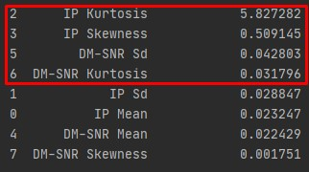

In the below part of the running python script (*Feature_importance.py*), we can see the metrics when the model takes into account all the features and when the model uses only the 4 important features based on *model.coef[0]*.

**All** the features **with** PCA :  
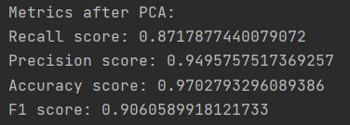

**Only** 4 important features (*IP Kurtosis, IP Skewness, DM-SNR, DM-SNR Kurtosis*)  
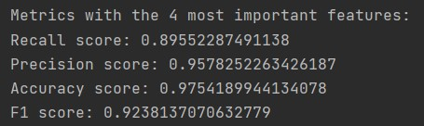

Comparing the 4 metrics with each other we observe that when the algorithm takes into account **only the 4 most important features** the metrics are larger which makes the model more **efficient** and more **accurate.**